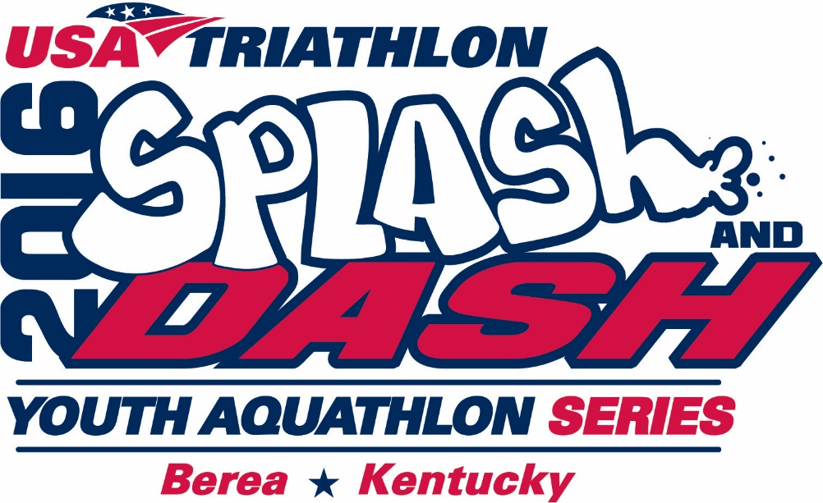

Daniel Boone Splash and Dash - June 25, 2016

Sponsorship Opportunities

### **PLATINUM SPONSOR $500**

* + Presenting sponsor with premiere recognition on signage and in printed materials
  + Special recognition at Finish Line Reception
  + Recognition on event website, enewsletter and Facebook

### **GOLD SPONSOR $100**

* + Sponsor listed on posters and flyers
  + Sponsor name announced with names of two youths as they cross the finish line
  + Photos of two participants displaying “I swim and run for INSERT SPONSOR NAME”
  + Recognition on event website, enewsletter and Facebook

##### **SILVER SPONSOR $ 50**

* + - Sponsor name announced with name of one youth as they cross finish line
    - Photo of participant displaying “I swim and run for INSERT SPONSOR NAME”
    - Recognition on event website, enewsletter and Facebook

##### **BRONZE SPONSOR Under $ 50**

* + - Recognition on event website, enewsletter and Facebook

Daniel Boone Splash and Dash - June 25, 2016

Sponsorship Form

**YES,** I would like to sponsor the Daniel Boone Splash & Dash Event on June 25th at the Berea Parks & Recreation Pool & City Trails.

_____ **Platinum Sponsor** - $500

_____ **Gold Sponsor** - $100

_____ **Silver Sponsor** - $50

_____ **Bronze Sponsor** - $__ (under $50)

List sponsor name as you would like it to appear:

#### Sponsor Name ________________________________________________________________

#### Contact Name _________________________________________________________________

Address ______________________________________________________________________

City ___________________________________ State ______________ Zip _______________

Email Address (optional) _________________________________________________________

Telephone ____________________________________________________________________

_____ Enclosed is a check payable to Berea College EPG Program.

_____ Please send an invoice to the above address.

_____ Visa, MasterCard or Discover: Card # _______________Exp. Date ___________

Name as it appears on card ________________________________________________

Credit Card Billing Address _________________________________________________

**Please return no later than May 18, 2016 to:**

Peter Hackbert

Entrepreneurship for the Public Good

Berea College CPO __

Berea, KY 40404

859.___.___

peter_hackbert@berea.edu

**Why We Host a Splash & Dash Event?**

Obesity and sedentary activities are an escalating epidemic affecting many demographic groups, including children and adolescents. “Childhood obesity is at epidemic proportions in the United States,” states retiring U.S. Surgeon General David Satcher.

A major health concern for Kentucky is the high rate of obesity throughout the Commonwealth. Kentucky ranks 8th highest in obesity rates for 10 to 17-year-olds.

Sedentary activities, such as television viewing are considered one of the most modifiable causes of obesity in children. Recent parent-report and self-report data from a nationally representative sample of 3,155 children indicate that 8-18-year-old children spend an average of about 4.5 hours per day watching television and videotapes or playing video games.

An abundance of evidence exists to support the benefits of regular physical activity in the reduction and prevention of obesity, type 2 diabetes, cardiovascular disease, hypertension, other adverse metabolic alterations and elevated lipid profiles that will eventually lead to early-onset cardiac disease and other diseases.

In fact, one of the Kentucky healthcare goals is to reduce obesity rate of Kentuckians 10% by 2019.

The City of Berea Trail Town Committee recognizes these health concerns in Madison County and the seven adjacent counties of Jessamine, Clark, Rockcastle, Estill, Fayette, Jackson, and Garrard.

The Entrepreneurship for the Public Good (EPG) program students serve on various City of Berea Trail Town Committees. EPG has designed a community-based and community-driven Splash and Dash Event based on the USA Triathlon Youth Aquathlon model. An Aquathlon is a fun and fast-growing sport that combines swimming and running on the City of Berea Trails. This is event is sanctioned by the USA Triathlon, which means course maps, staff, a medical plan, among other items, have been reviewed and approved by USAT. The event will feature a swim/run combination and is open to youth ages 7-15. Berea’s Event is one of 50 events across the country selected in 2016 through an application process!

The Splash and Dash Youth Aquathlon Series:

* Exposes and educates Berea and Madison County youth to the multisport lifestyle, all while being involved in a fun, exciting, and safe atmosphere.
* Engages the community in supporting healthy lifestyles, valuing safety, inclusiveness, motivation and achievement through exercise, participative competition and the pursuit of excellence.
* Creates an opportunity for participants to meet friends and other youth athletes who are interested and also engage in the multisport lifestyle!.

The event planning committee or USAT Splash and Dash Youth Aquathlon host requirements includes the maximum entry fee of $35 and youth annual USAT membership fee of $10.

**The Website Content**

*Most of this is included in the cover letter for the mail piece.*

**Scholarship Youth Sponsors**

* EPG and the City of Berea Trail Town Committee have organized a high-quality, safe, and fun multisport youth event in our community to stimulate a culture of healthy and active living.
* As a Splash and Dash sponsor, you will support a community youth aged 7-11 to engage in and be inspired to a culture of healthy and active living.
* You will reach a highly sought after demographic of active, health-conscious, youth and families in Madison and surrounding counties.
* If you are interested in sponsoring a Splash and Dash event, please enter your email and a Sponsorship Opportunities form will be sent to you providing a variety of event sponsorship levels.